
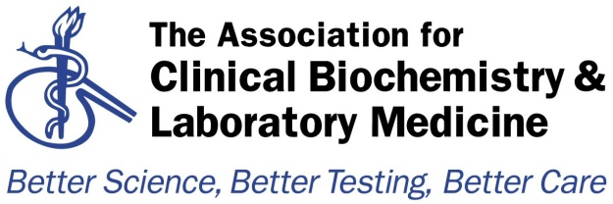

Audit Template
Audit Title: A regional (Scotland) audit of laboratory analyses for poisoned patients

Lead Auditor: Dr Heather Holmes | Audit date(s): Oct-Nov 2018
Please indicate if: Regional Audit  Please indicate which hospital & location or region  Scotland | Report Author:  Name: Dr Heather Holmes  Email: heatherholmes1@nhs.net
Aims of the Audit: Consensus guidelines for the investigation of patients with suspected poisoning were formulated by the UK National Poisons Information Service and the Association for Clinical Biochemistry & Laboratory Medicine in 2002 and updated in 2014. The aim of this audit was to determine adherence to these updated guidelines in laboratories across Scotland. It also re-audited (inital audit 2002) laboratory practices for reporting common drugs, reviewing harmonisation of units, reference intervals / therapeutic ranges and telephone limits.
Audit Method and Outcome(s): The audit was carried out be questionnaire sent to clinical and audit leads in all 14 Health Boards. All laboratories offer urgent analysis of the supportive investigations recommended in cases of acute poisoning, either within the laboratory or by point of care testing. All offer carboxyhaemoglobin, ethanol, iron, methaemoglobin, paracetamol and salicylate analysis urgently on a 24h basis. All offer digoxin, lithium, theophylline and valproate urgently apart from a few that refer elsewhere. Only 3 laboratories are able to offer urine paraquat testing out of hours, with a further 2 offering a service during core hours. Most laboratories are able to offer carbamazeine, phenobarbitone, phenytoin and thyroxine urgently, or next day by referral. Four laboratories offer ethylene glycol and methotrexate analysis and 3 offer methanol analysis. Others have arrangements in place to refer requests to these laboratories if urgent analysis is required but this may involve extensive sample transport. Arsenic, lead and mercury are only available in one laboratory. Four Health Boards indicated that they could refer samples for cyanide analysis, but two indicated that they refer to Cardiff who don’t currently offer the test. No laboratories are able to offer analysis for thallium or plasma paraquat. All laboratories have now adopted the use of mass units for drugs with the (appropriate) exceptions of lithium, methotrexate and thyroxine. There was some deviation in reference intervals/therapeutic ranges and phoning limits from those proposed by the Pathology Harmony Group and RCPath, respectively. Some are not aware of, or did not have consistent protocols in place for, potential interference in drugs assays (e.g. Digibind, desferrioxamine, NAPQI).

Audit Recommendations / Standards:
1. Laboratories should review therapeutic ranges, phoning limits and referral laboratories and be able to justify their decisions.
2. Laboratories should be aware of potential interferences in drug assays and have protocols for offering clinical and interpretative advice.
Please indicate to whom and when audit presented &/or circulated &/or published:
Oral and poster presentations at the National ACB Audit Meeting 2019, London.

Audit recommendations / standards ratified by … and when:

Date of audit report: Sep 2019

Audit documents for upload to http://www.acb.org.uk/whatwedo/science/audit.aspx
Please include as attachments with this Audit Summary form if authors and the organising committee would like information to be publicly accessible on the ACB website Audit section.

Poster and Powerpoint Presentation
Standards/Recommendations
Blank Survey Questionnaire

