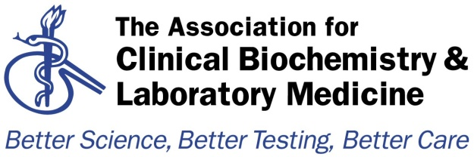

Audit Template
Audit Title:
An Audit on Sweat Testing in the Thames Region

Lead Auditor:  Dr Nikola Costa | Audit date(s):  July 2015
Please indicate if Local / Regional / National Audit  Please indicate which hospital & location or region | Report Author:  Name: Dr Nikola Costa  Email: Nikola.costa@nhs.net
Aims of the Audit:
An audit was conducted in the Thames Region to investigate how laboratories conduct sweat testing of patients for the diagnosis of Cystic Fibrosis, based upon the recently updated guidelines endorsed by the Royal College of Paediatrics and Child Health (Guidelines for the Performance of theSweat Test for the Investigation ofCystic Fibrosis in the UK, 2nd Version, An Evidence Based Guideline, March 2014).
The aim was to investigate whether hospitals in our region had adopted these new guidelines, identify any differences in practice and inform centres of the best practices as recommended and help identify areas for improvement. common practices of their analysis, including sample types, sample handling and transportation, methods, reference ranges and clinical interpretation. The responses were used to devise Best Practice Guidelines for the analysis of these metabolites.

Audit Method and Outcome(s):

An audit questionnaire was distributed by e-mail to the laboratories of the Thames region and responses collated. Participating laboratories were asked about their provision for sweat testing analysis, their common practices regarding the pre- and post-analytical processes, including quality assurance. The findings of the audit were presented to the region in a half day meeting. The results of the audit were discussed and discrepancies to the best practice guidelines were highlighted and areas for improvement summarised.
A total of 21 laboratories responded to the audit and their questionnaire answers were collated. A number of hospital centres were noted to be complying with the majority of best practices as described in the new guideline, in particular the adoption of the new age-related reference ranges . All laboratories were using approved sweat collection apparatus and laboratory methods and measuring the appropriate analytes, and also all labs were undertaking appropriate internal quality control and external quality assurance measures.

However the audit also highlighted some differences in the pre- and post-analytical handling of the samples, in particular how or when the samples should be transported to the laboratory,the accurate estimation of sample volume and hence adequate sample collection, some labs were analysing non-approved analytes (sweat sodium) or using non-recommended reference ranges and some labs were not reporting clinical interpretive comments.

Audit Recommendations / Standards:
The updated March 2014 guideline is very thorough and provides appropriate, evidence-based best practice recommendations for the investigation of Cystic Fibrosis by sweat testing analysis, and therefore this audit is not recommending any changes or additional standards.

However, the audit did highlight areas of improvement for those labs who participated in this audit and discovered discrepancies in their practice. These areas include:
- Assessment of adequate sample collection
- Use of correct age-related reference ranges
- The correct identification of contaminated samples
- Provision of interpretive comments, guidance for further testing
- Laboratory-led regular review of testing performance and clinical outcome (to comply with ISO standards).

Please indicate to whom and when audit presented &/or circulated&/or published:
Audit findings presented at the meeting of the Thames Audit Group on 31stJuly 2015.

Audit recommendations / standards ratified by … and when:
Recommendations ratified by the Thames Audit Group committee on 31st July 2015.

Date of audit report:
31/07/2015
Audit documents for upload to http://www.acb.org.uk/whatwedo/science/audit.aspx

