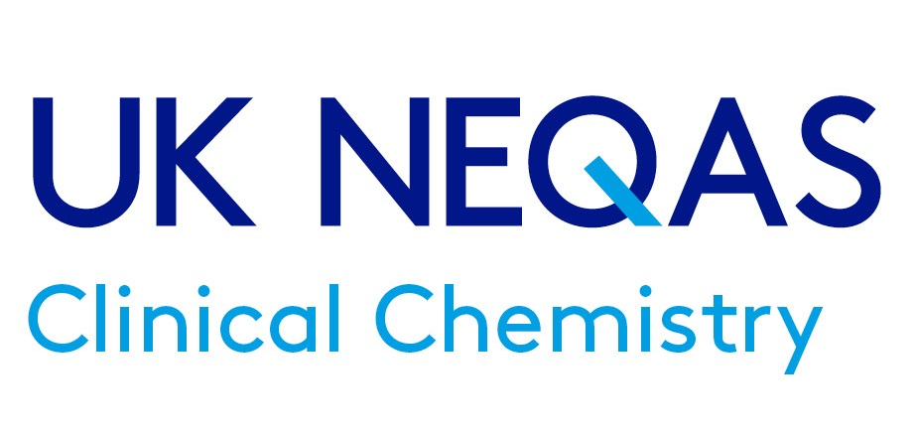

LabMed Southern Region and UK NEQAS Clinical Chemistry meeting to celebrate the career of Les Perry: Immunoassay through time.
Monday 22nd April 2024, 6 Alie Street, London
This form should be used for Poster Abstracts
Please do not change the font, font colour or font size on the form below.
Please, do not remove or change the headings.
Length of the abstract max 300 words.
References are optional.
Please send to alexander.read@nhs.net using the subject line SR/UKNEQAS Poster Submission

Title of the Abstract.

Presenters First name Last name*, First name 2 Last name 2, First name 3 Last name 3, etc.
*Organization, City, Country, Email address
Introduction
Enter text

Aims
Enter text

Methods
Enter text

Results
Enter text

Conclusions
Enter text

¹ References
² References

I certify that all authors on the abstract have contributed to a substantial part of the work discussed in the abstract
Yes: ☐ No: ☐

I hereby give permission to the Association for Laboratory Medicine to make my submitted abstract available electronically to delegates:
Yes: ☐ No: ☐

