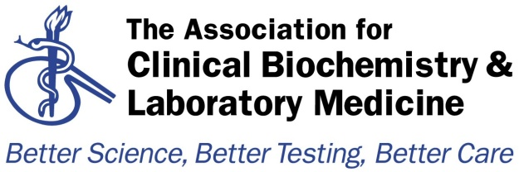

Audit Template
Audit Title:
Laboratory Analyses for Poisoned Patients

Lead Auditor:  Heather Stoddart | Audit date(s):  23rd March 2015
Please indicate if Local / Regional / National Audit  Please indicate which hospital & location or region  Regional: Thames Audit Group | Report Author:  Name: Heather Stoddart  Email: heather.stoddart@fhft.nhs.uk
Aims of the Audit:
To determine adherence to the 2014 document “Guidelines for laboratory analyses for poisoned patients in the United Kingdom” (Ann Clin Biochem 2014 Vol. 51 (3) 312-325).

Audit Method and Outcome(s):

An audit questionnaire was devised by the lead auditor and ratified by the Thames Audit Group (TAG) committee. It was then circulated to all members of the TAG and the responses analysed by the lad auditor. The findings were presented by the lead auditor at the meeting of the TAG on 23rd March 2015.
Recommendations were drafted by the lead auditor, discussed and amended by the TAG committee and then further discussed and amended at the TAG meeting. The recommendations were ratified by the TAG committee at the meeting on 31st July 2015.

Audit Recommendations / Standards:
- Laboratories should follow the recommendations for availability of laboratory analyses in the 2014 UK Guidelines as far as is practical (Thompson et al, Ann Clin Biochem 2014 51:312)
- The following analyses should be available 24/7 in all acute hospitals with a maximum 2 hour turnaround where practical.
If analysis is not available on site, (e.g. in laboratory networks where analysis is provided from one site), arrangements should be in place such that results can be provided within 2h in cases of suspected poisoning.
FBC, sodium, potassium, urea, creatinine, glucose, calcium, albumin, magnesium, INR, transaminases, bilirubin, anion gap (chloride & bicarbonate), osmolality & osmolar gap, arterial blood gases, creatine kinase, COHb, digoxin, ethanol, iron, lithium, methaemoglobin, paracetamol, salicylate, theophylline, valproate
- The following analysis should be available urgently on request.
Where necessary, laboratories should ensure that arrangements are in place with referral laboratories for these analyses to be available urgently if required, including out of hours where practicable. Ideally, these arrangements should be formal (e.g. SLA).
Arsenic, carbamazapine, cholinesterase, cyanide, ethylene glycol, lead, mercury, methanol, methotrexate, paraquat (quantitative plasma), phenobarbital, phenytoin, thallium, thyroxine, toxicology screen
- Laboratories should be aware of the potential for unreliable results in patients receiving treatment for poisoning. Antibody administration in digoxin poisoning interferes with immunoassay methods, and desferrioxamine treatment for iron overload can give false results in colorimetric assays.
- Laboratories should ensure that arrangements for these analyses are clearly documented and available to staff working out of hours, including those acting as Consultant on Call.
- Laboratories should, wherever practical, adopt the recommendations of the Pathology Harmony group for reference / therapeutic ranges and reporting units.
- Laboratories should consider the provision of a paraquat testing service, and ensure that the procedure for handling a potential request is documented and available to staff including those working OOH and acting as Consultant On Call.

Please indicate to whom and when audit presented &/or circulated&/or published:
Audit findings presented at the meeting of the Thames Audit Group on 23rd March 2015.

Audit recommendations / standards ratified by … and when:
Recommendations ratified by the Thames Audit Group committee on 31st July 2015.

Date of audit report:
23rd March 2015
Audit documents for upload to http://www.acb.org.uk/whatwedo/science/audit.aspx

