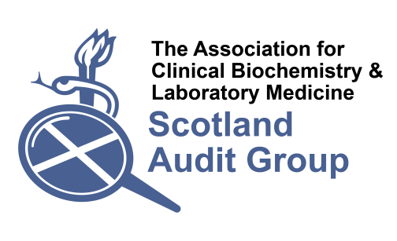

Audit of Laboratory Analyses for Poisoned Patients

Health Board:

Hospital(s):

Supportive Investigations
- Are the following tests available 24/7 within your laboratory or via Point of Care? If no, please specify your arrangements for providing these tests.
 | POCT (Y/N) | Lab (Y/N) | Other arrangements
Full blood count
Sodium, potassium, urea, creatinine
Glucose
Calcium, albumin, magnesium
INR
ALT, bilirubin
AST
Chloride, bicarbonate (Anion gap)
Plasma osmolality
Arterial Blood Gas
Creatine Kinase

Assays that should be available on a 24 hour basis in all acute hospitals
- Are the following tests available within your hospital laboratory or via POCT?
 | Available at POCT | Available 24hr in lab | Available 24hr following discussion | Available during normal working hours | Referred  If so, where | Not available
Carboxyhaemoglobin
Digoxin
Ethanol
Iron
Lithium
Methaemoglobin
Paracetamol
Paraquat (qualitative urine test)
Salicylate
Theophylline
Valproate

- If possible, please can you provide the annual workload, target turnaround time, reporting units, reference range (if appropriate) and any phoning limits.
 | Annual workload* | TAT | Units | Reference range | Phoning limits
Carboxyhaemoglobin
Digoxin
Ethanol
Iron
Lithium
Methaemoglobin
Paracetamol
Paraquat (qualitative urine test)
Salicylate
Theophylline
Valproate
*If possible please do not include requests for therapeutic drug monitoring, only requests where an overdose has been taken or suspected. If overdoses are not counted separately in your workload statistics please estimate the number of overdoses.

Specialist or infrequent assays
- Are the following tests available within your laboratory, or referred out, and are you able to provide or make arrangements for urgent analysis in cases of suspected poisoning?
 | Available in lab  (Y/N) | Referred (Y/N), if so where? | Available urgently (Y/N) | Not available
Arsenic
Carbamazepine
Cholinesterase (plasma & erythrocyte)
Cyanide
Ethylene Glycol
Lead
Mercury
Methanol
Methotrexate
Paraquat(quantitative plasma assay)
Phenobarbitone
Phenytoin
Thallium
Thyroxine
Toxicology Screen

- If possible, please can you provide the annual workload, target turnaround time (for an urgent request), reporting units, reference range (if appropriate) and any phoning limits.
 | Annual workload* | TAT for urgent requests | Units | Reference range | Phoning limits
Arsenic
Carbamazepine
†Cholinesterase (plasma & erythrocyte)
Cyanide
Ethylene Glycol
Lead
Mercury
Methanol
Methotrexate
Paraquat(quantitative plasma assay)
Phenobarbitone
Phenytoin
Thallium
Thyroxine
Toxicology Screen
*If possible please do not include requests for therapeutic drug monitoring, only requests where an overdose has been taken or suspected. If overdoses are not counted separately in your workload statistics please estimate the number of overdoses.
†Please do not include requests for suxamethonium sensitivity – the question relates to possible organophosphate poisoning.

Additional questions about specific tests

Digoxin
- Do you have a policy, procedure or recommendation for digoxin measurement in patients receiving digoxin-specific antibodies (Digibind)? If yes, please give details

Iron
- Do you accept haemolysed samples for iron analysis? Please state at what haemolysis index/cut off you would reject.
- What is the principle of your iron assay? Do you have a policy, procedure or recommendation for iron measurement in patients receiving desferrioxamine?

Paraquat
- If you provide a paraquat service from your laboratory, please attach a copy of your protocol, including the training and competency procedures in place.

Ethylene Glycol/Methanol
- Do you provide a protocol for assessment of acidosis, anion gap and/or osmolar gap for patients with suspected ethylene glycol or methanol toxicity? If yes, please give details.

Paracetamol
- Is your lab aware of interference by NAC or NAPQI in enzymatic creatinine or other Trinder based assays?

